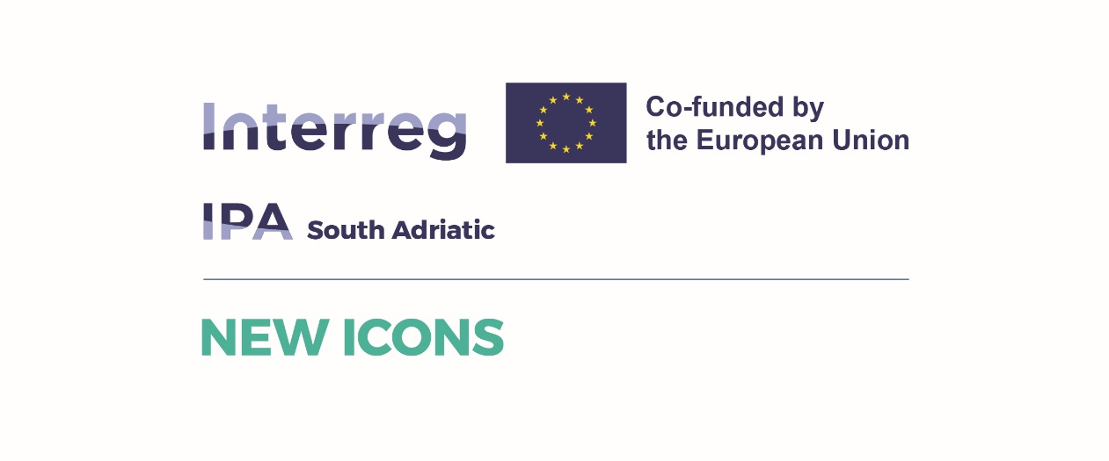

***NEW ICONS Conference***

***BSC Bar, Bar 5th June 2025***

**Draft agenda**

|  |  |
| --- | --- |
| **09:00 – 09:15 Registration welcome greetings – hosting the event** | |
| **09:15 Start of the meeting Session 1** | |
| **ITEM 1** | **Topic: NEW ICON project results and outcomes**  ***Moderator: Ivana Tomasevic*** |
| **Contents and inputs** | * Presenting the NEW ICONS project results – LEAD Partner * Presenting Research that led to Action plan and activities in upcoming period – Molisse Partner presenting the study and requirements, Albania and Montenegro presenting their Action plans * **Questions and discussion** |
| **Expected output** | Boosting the visibility of the needs for women in tourism and upcoming activities for supporting them  Promotion of NEW ICONS CLUSTER |
| **10:00-10:15 – Coffee Break**  **10:30 Start of the meeting Session 2** | |
| **ITEM 2** | **Topic: Importance of international networking and B2B activities – Tanja Raduisinovic Chamber of Economy in Montenegro** |
| **Contents and inputs** | * This topic will cover the presentation of benefits of networking and joining associations, opportunities and platforms that can be used to support women business like Enterprise Europe Network platform * Presentation of companies – guests that are members of NEW ICONS CLUSTER from Italy, Albania and Montenegro |
| **Expected output** | * Presenting the international network to new stakeholders. * Promoting of existing members of NEW Icons Cluster * Connecting companies and strengthening partnerships and business connections in the Area. |
| **ITEM 3** | **Topic: Digitalization and visibility in tourism business – Ivana Ognjanovic, UDG** |
| **Contents and inputs** | * Importance of digitalization in business and benefits for SMEs * Best case examples and what can be imeddiately achieved * The importance of visibility and promotion of woment tourism business |
| **Expected output** | * Participants will gain new knowledge - skills in supporting their business with digital tools, quality of visibility |
| **Lunch for participants 13:00-14:00**  **14:00 Start of the meeting Session 3** | |
| **ITEM 4** | **Topic: Access to finance for Women SMEs and Joint activities**  **Modeator: Municipality of Bar** |
| **Contents and inputs** | * Presenting the funding allocated by Municipality of Bar and other donors support * Presenting the best cases * Results of support and what is needed directly from business – SMEs share their experience and networking needs * Presentation of Joint Commitment document |
| **Expected output** | * In this occasion Partners will sign a Joint Commitment document for testify their commitment to apply the Joint Action Plan well beyond the project implementation |
| **16:00 End of the event** | |